Optus X Lite 4G

Type of device: Mobile
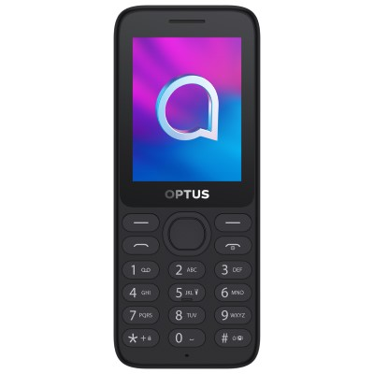

Actual Display Size : 2.4 inches
Button Type : Physical Keypad
Network Capability : 3G,4G
Year of Release : 2022
Average Price : $54 as of 19 05 2022
Other :

Accessibility Features:

Cognitive
- Copy and Paste
- Screen Timeout Disabled
- Simple Instructions
- Simplify Display
Voice Notes

Hearing Impairment and Deaf
- Bluetooth or Wi-Fi
- Text Messaging/SMS
Visual Alerts - Incoming Calls

Vision
- Battery Alert - Audible
- Bluetooth or Wi-Fi
- Brightness Adjustable
- Key Marker – Raised '5'
- Key Numbers - Standard Layout
Key Press - Vibration or Click

Speech
- Bluetooth or Wi-Fi
Messaging Options - MMS

Physical
- Bluetooth or Wi-Fi
- Guarded/Recessed Keys
- Headset - plug connected
Physical Dialling Keys

How and where to get it from?
You can buy this phone from Optus, Coles, Big W, Woolworths, and other retailers.

More information is available on:
Optus X Lite 4G Quick Start Guide PDF Website
Optus X Lite 4G website

